Press Release

Contact: Yoo Eun-shik(+82 61-270-2042), Seo Hyeon-ju(+82 61-270-2054)
Exhibitions & Cultural Events, National Research Institute of Maritime Cultural Heritage

Inauguration of Special Exhibition
Korean War and Hope(July 30 – September 6, 2020)

Co-hosted by the National Research Institute of Maritime Cultural Heritage, Jeollanamdo Office of Education, and Jeollanamdo Western Regional of patriots and veterans Affairs

The National Research Institute of Maritime Cultural Heritage (Acting Director: Shim Yeong-seop), an affiliate of the Cultural Heritage Administration, together with the Jeollanamdo Office of Education (Governor: Jang Suk-woong), and Jeollanamdo Western Regional of patriots and veterans Affairs (Director: Park Young-suk), is pleased to present the special exhibition, Korean War and Hope, at the Maritime Museum (located in Mokpo, Jeollanam-do Province) from July 30 to September 6.

In commemoration of the 70thanniversary of the outbreak of the Korean War, the exhibition features eighty photographs capturing the lives of the people of the Jeollanam-do Province from the proclamation of independence to a ceasefire in the Korean War. Together with the photographs will be showcased fifteen educational materials related to school life at the time of the war including textbooks, letters of appointment, and report cards.

The exhibition consists of three sections. “Part I. Springtime on the Korean Peninsula: The Restoration of Korea’s Independence” offers a glimpse of the festive atmosphere that developed in Jeollanam-do Province following liberation from Japanese colonial rule through photographs of the monument and parade celebrating independence. Also presented in this section is a photograph of Kim Gu that he took together with the Women’s Patriotic Association in 1946 on his visit to Mokpo. “Part II. A Tragedy in Korea: The Korean War” shows the horrors of the Yeosu-Suncheon Incident of 1948, together with images of the major battles of the Korean War as well as those of soldiers and prisoners. Moreover, photographs of women’s militia and civilian support troops, which had not been widely introduced until the present, will be exhibited, and are expected to garner much interest from the public. Lastly, “Part III. Hope Blooming in the Midst of War” displays photographs embodying people’s struggles to restore peace and balance in their daily lives, in particular, the efforts to keep children in education even during war and to care for war orphans in local welfare facilities.

Through the exhibition, the National Research Institute of Maritime Cultural Heritage aims to offer an opportunity to remember the numerous sacrifices that have helped maintain peace in Korea and the lives of the people of Jeolla-do region, who continued to search for new hope amid the ruins of war. The Institute will exert extended efforts to expand collaboration with local organizations to provide a diverse assortment of exhibition services.

The exhibition will be available for online viewing through a video tour uploaded on the website (http://www.seamuse.go.kr), Facebook page, and YouTube channel of the Institute. To prevent the further spread of COVID-19, visitors to the museum are required to wear a mask and to maintain a physical distance from other individuals.

붙임: 안내홍보물과 사진
Attachments: Exhibition Poster and Photographs

붙임 1: Attachment 1
안내 홍보물: Exhibition Poster

붙임 2: Attachment 2
사진자료: Photographs

제 1부: 민족의 봄, 광복
I. Springtime on the Korean Peninsula: The Restoration of Korea’s Independence
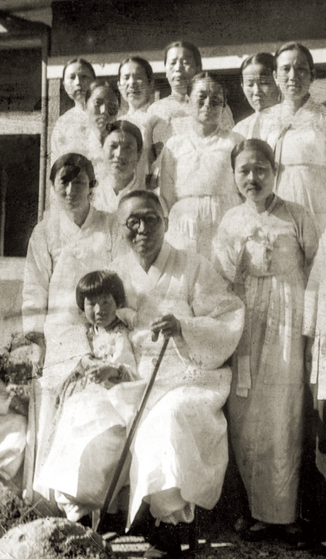
Kim Gu Visits Mokpo the Year Following the Proclamation of Independence
(1946, MokpoTaehwaMojawon)

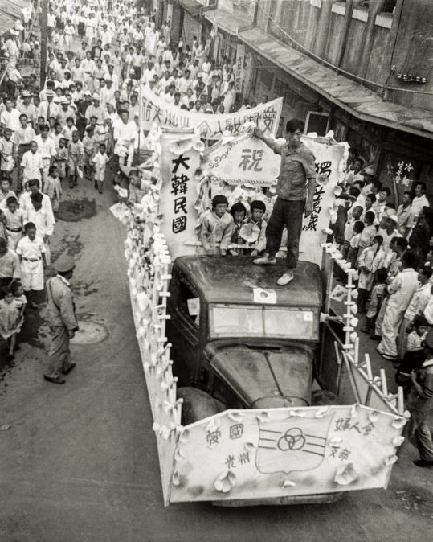
Members of the Gwangju Branch of the Women’s Patriotic Association and the People of Gwangju Parade across Chungjang-ro in Celebration of the Proclamation of Independence
(August 1945, photo by the late Yi Gyeong-mo)

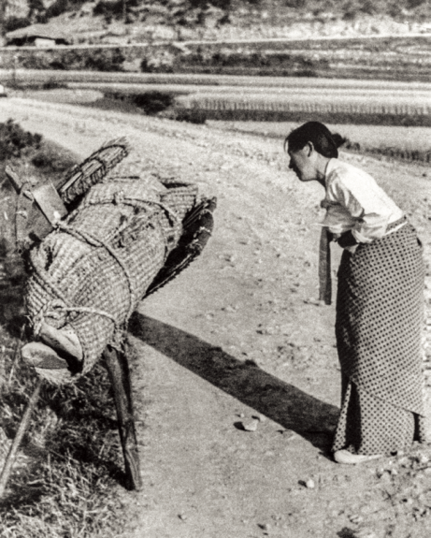
제 2부 민족의 비극, 6·25전쟁
II. A Tragedy in Korea: The Korean War
Woman Crying before Her Younger’s Brother’s Corpse
(1948-1949, photo by the late Yi Gyeong-mo)

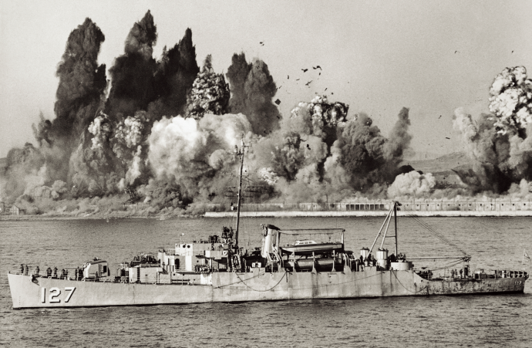
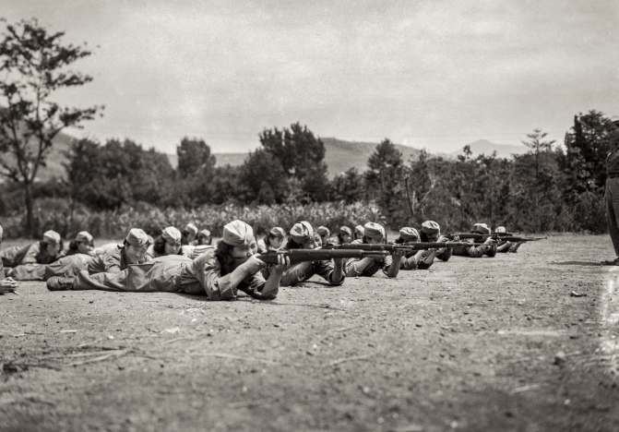
Heungnam Dock under Demolition behind USS Begor
(December 24, 1950, Bae Jae-hun)

Women’s Militia Training for War
(1951, National Archives of Korea)

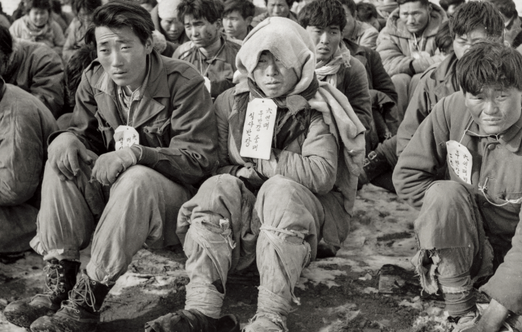
Soldiers of the North Korea People’s Army and War Prisoners
Gathered around an Open Area in Damyang, Jeollanam-do Province
(February 1952, photo by the late Yi Gyeong-mo)

제3부. 전쟁 속 꽃피는 희망
III. Hope Blooming in the Midst of War

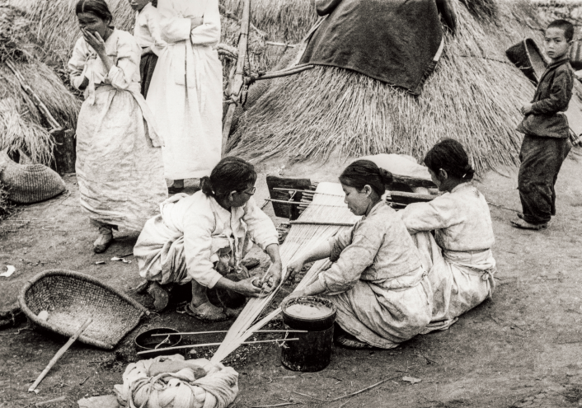
Female Refugees in Hwasun, Jeollanam-do Province
(April 1951, photo by the late Yi Gyeong-mo)

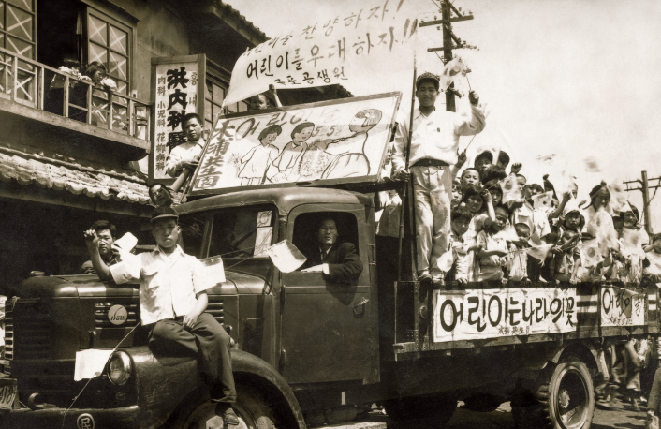
Children’s Day Parade before the Armistice
(May 1953, Mokpo Gongsaengwon Orphanage)

