Press Release  17 Nov 2020 | FOR IMMEDIATE RELEASE  Contact  Kim Donghyon, Research Division 2  Tel: +82-2-6902-0732 Fax: +82-2-6902-0799  www.overseaschf.or.kr

Return of an “Angbuilgu” Sundial,
the Epitome of Joseon Scientific Technology and Reflection of the King’s Love for the People

The Cultural Heritage Administration (Administrator Chung Jae-suk) will be making an Angbuilgu- a sundial from the Joseon Dynasty -available to the press at the National Palace Museum of Korea (Director Kim Dong-young) at 2 PM on November 17. This sundial went on auction in the United States and was purchased this past June by the Overseas Korean Cultural Heritage Foundation (Chairman Choi Eungchon).
Under the authority of the Cultural Heritage Administration, the Overseas Korean Cultural Heritage Foundation collected information about this sundial last January and conducted a close research and investigation of the item, including scientific analysis for comparison with other metal sundials housed in Korea. The scheduled auction of the sundial was postponed several times from March to June due to the COVID-19 pandemic, but it was finally brought home to Korea in August.
The classical Chinese characters comprising the term “Angbuilgu” respectively mean “looking up at the sun”(仰, ang), “cauldron”(釜, bu), “sun”(日, il), and “shadow”(晷, gu), which together indicate “a sundial that tells time by the shadow of the sun cast over its cauldron-shaped body.” Angbuilgu sundials testify to the advanced science of the Joseon period and are symbolic of the Joseon king’s love for the people.
The returned Angbuilgu sundial is believed to have been produced between the eighteenth and early nineteenth century. It measures 24.1 centimeters in diameter and 11.7 centimeters in height and weighs around 4.5 kilograms. The use of elaborate metal casting methods, refined silver inlay decoration, dragon and turtle head designs on the legs, and other features attest to advanced level of science and artistry measuring seasons and time in Korea at the time, and render it a high-quality work of art produced by skilled artisans.
In ancient Confucian states, the king would observe the celestial bodies in order to inform the people of solar terms and the correct time. This was considered one of the most important royal duties, and Angbuilgu sundials were designed to serve this aim, thus reflecting the king’s love for the people. Angbuilgu sundials were the first public chronographs produced in Joseon, dating from the reign of King Sejong through the late Joseon period. King Sejong commissioned the first Angbuilgu sundials and ordered them mounted in front of the Jongmyo Ancestral Shrine and Hyejeonggyo Bridge (present-day Jongno 1-ga) so that people could know the time. Angbuilgu sundials make little time difference when compared with certain modern time standards. They are accurate and systematic scientific instruments that can inform users about the subdivisions of the seasons (a climatological standard based on 24 divisions of the year), bearings, sunset time, and directions.
Despite their high value, few scientific instruments from the Joseon period managed to be preserved and are known today only through historical records. Only seven of these large metal Angbuilgu sundials exist in Korea.
The retrieved Angbuilgu sundial only gives the correct time when it is calibrated for the latitude installed at Hanyang (Seoul). The return of the Angbuilgu sundial is indeed meaningful as it has finally been returned to its home country and can again give the correct time.
The National Place Museum of Korea will take care of the Angbuilgu sundial and utilize it along with other scientific cultural properties such as the Jagyeongnu water clock and Honcheonui armillary sphere for research, exhibition, publications, and other diverse purposes. This Angbuilgu sundial will be displayed to the public at a special exhibition held in the Science Culture Gallery of the museum starting Wednesday, November 18, the day following the press viewing.
Despite the many difficulties imposed by the COVID-19 pandemic, the Cultural Heritage Administration successfully retrieved this Angbuilgu sundial as part of its contributions to the Government Innovation and Active Administration campaigns. Spurred by this achievement, the Cultural Heritage Administration will continue to make sincere efforts to discover and retrieve precious Korean cultural heritage currently residing abroad.

Appendix: Photo material. End.
[Att.] Photo material

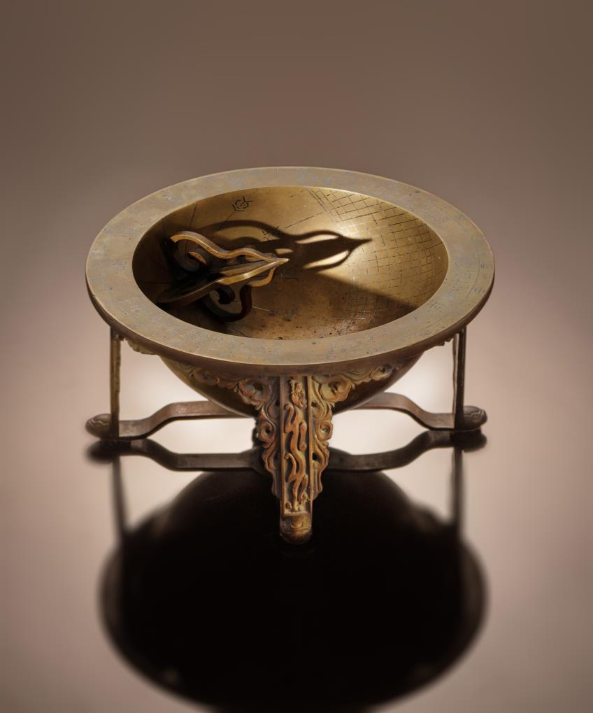
Photo 1. Angbuilgu

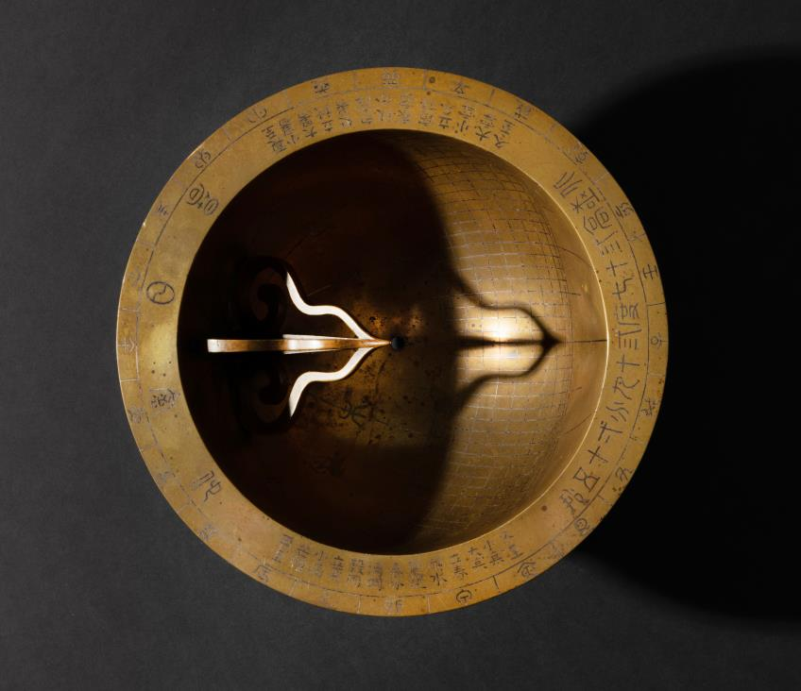

Photo 2. Upper side of Angbuilgu

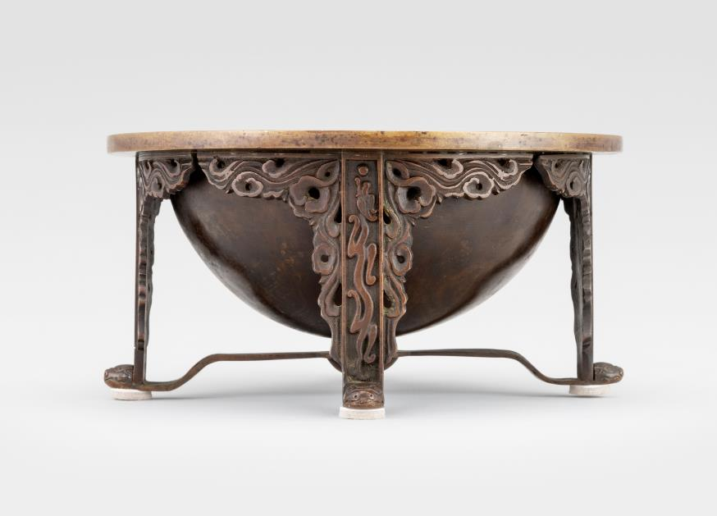

Photo 3. Lateral side of Angbuilgu

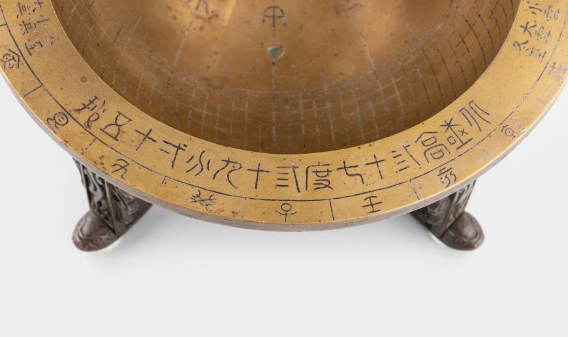

Photo 4. Silver inlay of North latitude 37°39′15″
(北極高三十七度三十九分一十五秒)

