 | 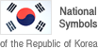 | Cultural  Heritage Administration  NEWS
Division: The National Palace Museum of Korea
Exhibition & Publicity Division
Contact person: Lim Gyeong-hee (02-3701-7631),
Lee Ji-hye (02-3701-7634)

The National Palace Museum of Korea Presents the Document Bestowed by the King to His Subject for Practicing Archery Together as the Curator’s Choice for May
– Record of a Gift Bestowed by King Jeongjo on a Military Official, Who Congratulated the King for His Bullseyes, to Be Showcased Both in the Gallery and Virtually Via YouTube – May 3

The National Palace Museum of Korea (Director: Kim Dong-Young), an affiliate of the Cultural Heritage Administration of Korea, has selected Document Bestowed by the King to His Subject for Practicing Archery Together as the “Curator’s Choice from the Royal Treasures” for the month of May. In addition to being displayed in the gallery, the document will be presented in a video broadcast via the internet (on YouTube) starting May 3.
*National Palace Museum of Korea YouTube: https://www.youtube.com/gogungmuseum
Cultural Heritage Administration YouTube: https://www.youtube.com/chluvu

Gopung refers to a custom in which subjects attending the king request a gift as a gesture of congratulations after the king scored a bullseye in archery. It can also refer to a document containing the details of the king’s round and the gifts he bestowed. A gopung records the title of the document, name of the recipient, score earned by the king, date of the archery round, goods bestowed, and the king’s signature.

The Document Bestowed by the King to His Subject for Practicing Archery Together contains a record of a gift of five packs of herbal medicine bestowed by King Jeonjo (r. 1724–1776) on a military official named O Ui-sang, who congratulated the king for scoring nine bullseyes on the fifteen shots he made. Although simply a concise note, the document offers insight into the royal passion for archery during the Joseon Dynasty.

Royal archery records were also inscribed on hanging signboards and steles. A notable example housed in the National Palace Museum of Korea is a signboard recording the archery session held by King Heonjong (r. 1834–1849) at Danpungjeong Pavilion next to Chundangdae Pavilion on the fifteenth day of the seventh lunar month in 1842. The Document Bestowed by the King to His Subject for Practicing Archery Together and other documents and hanging signboards illustrating royal archery rounds are on display in the gallery of Royal Rituals of the Joseon Dynasty. Those who are unable to visit the gallery can still enjoy this month’s Curator’s Choice virtually through a video with Korean and English subtitles available on the museum’s website (gogung.go.kr) and on the YouTube channels of the museum and the Cultural Heritage Administration of Korea.

Attachment: Images
(Attachment)

Images
Promotional Material for Curator’s Choice – May
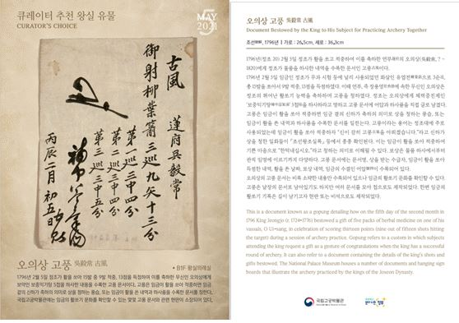
Writing on the Document Bestowed by the King to His Subject for Practicing Archery Together
